PROJECT -3

TITLE: -

Design and Manufacturing of timer circuit using NE555P.

OBJECTIVE: -

To design and manufacture a timer circuit using the NE555P IC that can be used for applications such as pulse generation, timing delays, and oscillator functions.

INTRODUCTION: -

The NE555P timer IC is a highly popular and versatile integrated circuit used for generating precise time delays or oscillations. It operates in various modes, such as monostable, astable, and bistable, making it ideal for applications like timers, pulse generators, and oscillators.

COMPONENTS AND SPECIFICATIONS: -

NE555P Timer IC:
- Description: A 555 timer IC in an 8-pin Dual Inline Package (DIP).
- Specifications:
  - Operating Voltage: 4.5V to 16V.
  - Output Current: 200mA maximum.
  - Timing Accuracy: Typically, within 1% of calculated value.
  - Temperature Range: 0°C to +70°C.

2. Resistors:
- Types: Fixed resistors or Potentiometer for timing configuration.
- Specifications:
  - Typical values: 1kΩ, 10kΩ, etc., depending on the desired timing.
  - Tolerance: ±1% for precise timing applications.

3. Capacitors:
- Types: Ceramic or electrolytic capacitors for timing and decoupling.
- Specifications:
  - Values: 10nF, 0.1μF, 1μF, etc., based on timing requirements.
  - Voltage Rating: Must be greater than the operating voltage (e.g., 25V).

4. Diodes:
- Types: Signal diodes (e.g., 1N4148) or power diodes (e.g., 1N4007) for protection and rectification.
- Specifications:
  - Forward Voltage Drop: Typically 0.7V for silicon diodes.
  - Reverse Voltage: Should withstand the circuit voltage (e.g., 50V or 100V).

5. Variable Resistor (Potentiometer):
- Description: Adjustable resistor used for tuning the timing duration.
- Specifications:
  - Typical Range: 10kΩ to 100kΩ.
  - Tolerance: ±10%.
6. Power Supply:
- Description: Provides the necessary voltage to the circuit.
- Specifications:
  - Voltage: Typically 5V, 9V, or 12V DC.
  - Current Rating: Sufficient to drive the load and the IC (e.g., 500mA).
7. Output Load:
- Types: Can be LEDs, relays, buzzers, etc.
- Specifications:
  - Ensure the load is within the output current capability of the NE555P (200mA maximum).

DESIGN PROCESS: -

- Schematic Design-

• Power Supply Connections:
- Connect the VCC pin (Pin 8) of the NE555P to the positive voltage rail.
- Connect the GND pin (Pin 1) to the ground rail.

• Configure the Timer Mode:
- For Astable Mode (continuous oscillation):
  - Connect Pin 2 (TRIG) and Pin 6 (THR) together.
  - Connect a resistor between VCC and Pin 7 (DISCH).
  - Connect another resistor between Pin 7 and Pin 6/Pin 2.
  - Connect a capacitor between Pin 6/Pin 2 and GND.

- For Monostable Mode (single pulse):
  - Connect a resistor between VCC and Pin 7 (DISCH).
  - Connect a capacitor between Pin 6 (THR) and GND.
  - Connect Pin 2 (TRIG) to a switch and to GND via a resistor.
  - Connect Pin 4 (RESET) to VCC.

• Control and Timing Capacitors:
- Connect a capacitor between Pin 5 (CV) and GND (typically 10nF).

• Output Configuration:
- Connect the load (e.g., LED with current-limiting resistor) to Pin 3 (OUT) and GND.

• Optional Diodes:
- Place diodes in the circuit to protect against reverse voltage or to shape the waveform as needed.

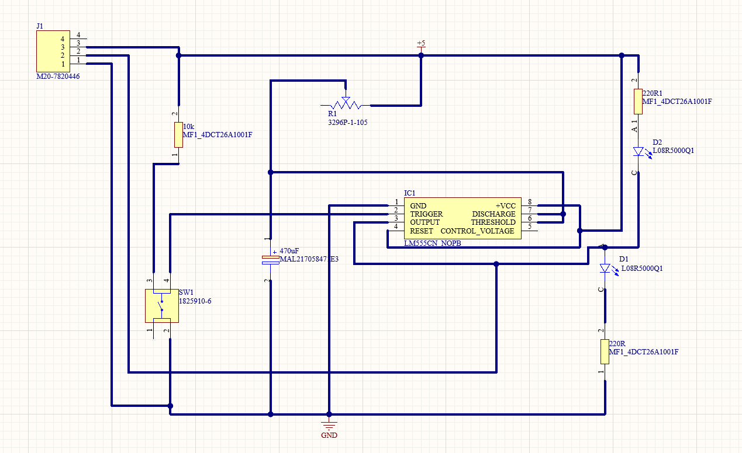

2. PCB LAYOUT:

Component Placement
- Microcontroller: Positioned centrally to minimize trace lengths to all components, with I/O pins accessible for easy debugging.
- Power Circuit: Voltage regulator (if used) and capacitors are placed near the power input for stable voltage.
- Trace Routing
- Power and Ground Traces: Wide traces are used for Vcc and ground to handle current and reduce voltage drops. A ground plane under critical areas minimizes noise and stabilizes signals.
- Signal Traces: Short, direct traces are used to prevent interference. Signal lines are routed away from high-current traces.
Clearance and Spacing
- Standard clearances are maintained throughout for safe soldering and reliable operation, particularly around high-voltage and sensitive areas.
Thermal Management
- Sufficient spacing is given around the voltage regulator for passive heat dissipation, ensuring stable operation over time.

Design for Assembly and Debugging
- Components are arranged to allow easy access to the programming header, debugging LEDs, and other critical points. The status LED is visible for quick feedback on board status.

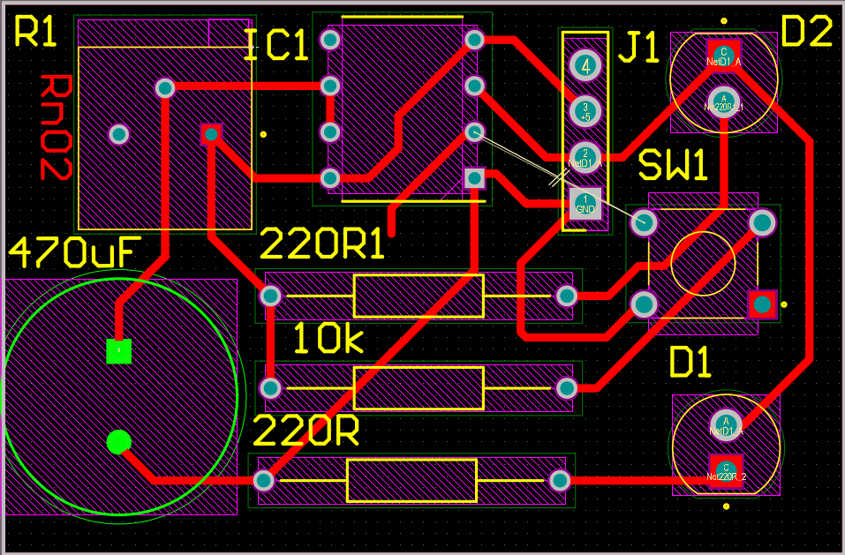

3. Assembly and Testing
Component Placement and Soldering
- After the PCB fabrication, components were carefully placed and soldered. Through-hole and surface-mount techniques were applied as required.
- Testing
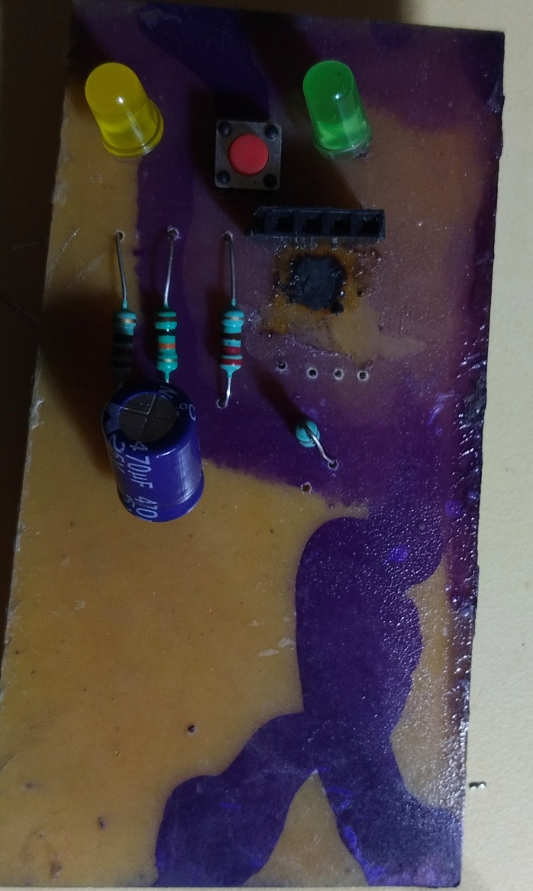
- Initial testing involved verifying power supply stability and ensuring no short circuits.
- Controlling a DC motion of 12V or and LEDs of 12V by varying the potentiometer’s resistance.
- Any issues found during testing, such as incorrect connections or component placement, were documented and rectified.

